**Results**

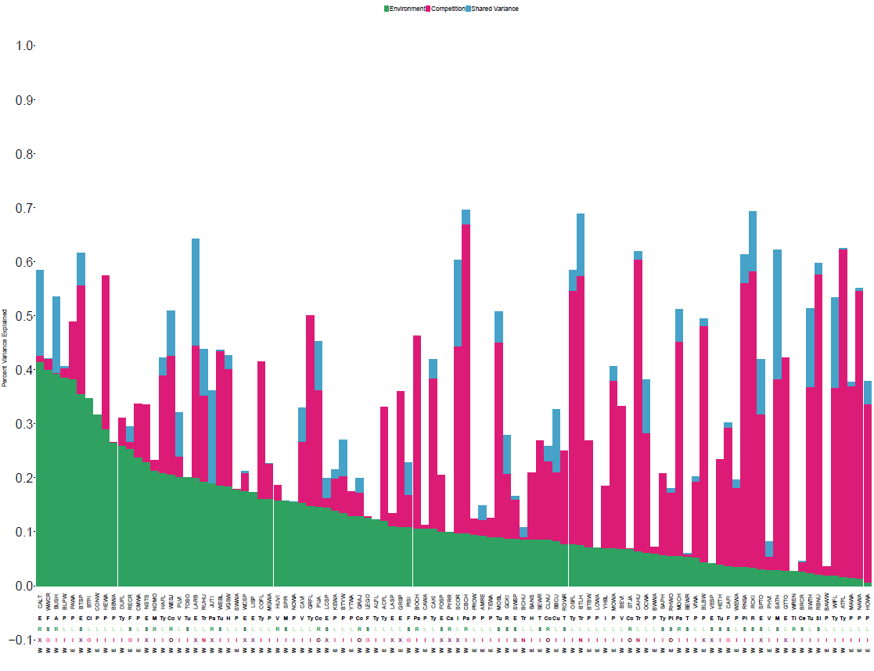

* Variance Partitioning
  + >50% variance explained for **23** species out of 102 – abiotic, biotic, shared
  + Avg of nnnn% total, nnnnn% env, and nnn% biotic variance explained for each focal spp
  + **Figure 2** = bar plot
* GLM ran occ
  + big AIC 512363.8
  + Residuals – -0.375-0.12, is this symmetrical?
  + Table 1

Generalized linear mixed model fit by maximum likelihood (Laplace Approximation) ['glmerMod']

Family: binomial ( logit )

Formula: cbind(sp_success, sp_fail) ~ c_s + abTemp + abElev + abPrecip + abNDVI + (1 | stateroute:Species)

Data: occumatrix

AIC BIC logLik deviance df.resid

512363.8 512433.6 -256174.9 512349.8 159458

Scaled residuals:

Min 1Q Median 3Q Max

-0.37545 -0.02061 -0.00616 0.02629 0.12318

Random effects:

Groups Name Variance Std.Dev.

stateroute:Species (Intercept) 1.965 1.402

Number of obs: 159465, groups: stateroute:Species, 10631

Fixed effects:

Estimate Std. Error z value Pr(>|z|)

(Intercept) 0.928309 0.029757 31.20 < 2e-16 ***

c_s -0.555911 0.013721 -40.52 < 2e-16 ***

abTemp -0.140683 0.024435 -5.76 8.53e-09 ***

abElev -0.024455 0.023475 -1.04 0.298

abPrecip -0.016267 0.022809 -0.71 0.476

abNDVI -0.007421 0.004792 -1.55 0.121

---

Signif. codes: 0 ‘***’ 0.001 ‘**’ 0.01 ‘*’ 0.05 ‘.’ 0.1 ‘ ’ 1

Correlation of Fixed Effects:

(Intr) c_s abTemp abElev abPrcp

c_s 0.009

abTemp -0.445 -0.025

abElev -0.431 0.009 -0.156

abPrecip -0.395 0.001 -0.165 -0.133

abNDVI -0.091 0.001 -0.003 -0.022 -0.031

Figure 3.

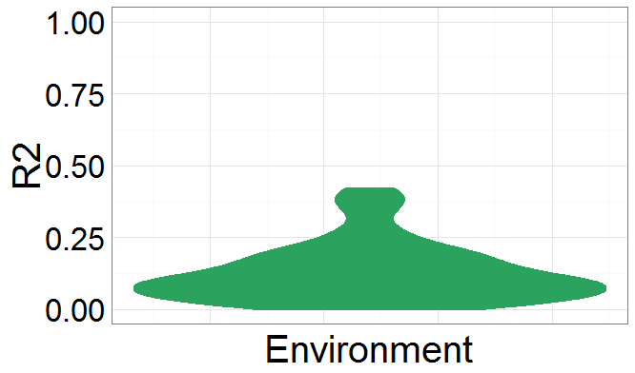 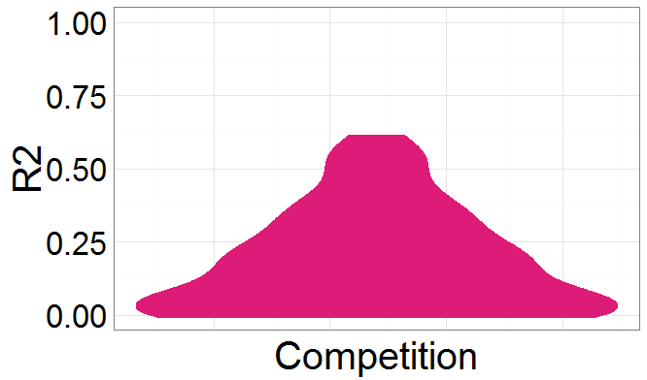 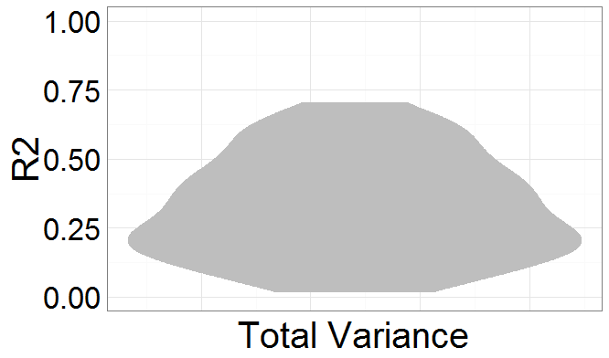

* Traits LM
  + Residuals – not symmetrical, so data not fit well by the model
  + t-statistic values not far away from zero and are small relative to the standard error, probably no relationship exists
  + adjusted R2 adjusts for the number of variables considered – 0.334
  + Table 2, Overall, seems like a poor model
* Call:
* lm(formula = logit(edgeval) ~ Trophic.Group + migclass + EW.x,
* data = env_sum)
* Residuals:
* Min 1Q Median 3Q Max
* -7.1634 -0.9130 0.2668 1.0931 2.9685
* Coefficients:
* Estimate Std. Error t value Pr(>|t|)
* (Intercept) -3.0213 0.4424 -6.829 5.64e-11 ***
* Trophic.Groupinsct/om 0.5470 0.4537 1.206 0.2290
* Trophic.Groupinsectivore 0.6013 0.4227 1.423 0.1560
* Trophic.Groupnectarivore 0.7742 0.6423 1.205 0.2291
* Trophic.Groupomnivore 0.7869 0.6120 1.286 0.1996
* migclassresid -0.1401 0.3538 -0.396 0.6924
* migclassshort -0.1338 0.2529 -0.529 0.5973
* EW.x -0.4178 0.2417 -1.728 0.0851 .
* ---
* Signif. codes: 0 ‘***’ 0.001 ‘**’ 0.01 ‘*’ 0.05 ‘.’ 0.1 ‘ ’ 1
* Residual standard error: 1.613 on 270 degrees of freedom
* (28 observations deleted due to missingness)
* Multiple R-squared: 0.02256, Adjusted R-squared: -0.002777
* F-statistic: 0.8904 on 7 and 270 DF, p-value: 0.5144
* Occupancy and Abundance
  + provide unique information about biodiversity (1:1) line – some species occupancy was better predicted than abundance and vice versa
  + **Figure 3/4**

